ICT OMELETTE
Prototype
D5.5 – Final service discovery, description and composition prototype



Title | D5.5 – Final service discovery, description and composition prototype
Editor | UPM
Contributors | UPM, TUC, TIE
Reviewers | Logica, T-Systems
Work Package | WP5 – Automated discovery, selection and composition
Task | T5.5 – Prototype of automated discovery, description and composition
Date | 26-11-2012
Release | 01.0
Status | Final
Distribution | Public

History
Release | Date | Remarks | Status | Distribution
1.0 | 26-11-2012 | Initial version (UPM) | Draft | Confidential

Index
History 2
Index 3
1. Executive Summary 4
2. Automatic discovery tools 4
2.1. Scrappy 4
2.1.1. Introduction 4
2.1.2. Installation 4
2.1.3. User manual 5
2.2. OMELETTE Mashup Registry 11
2.2.1. Installation of Sesame with uSeekM (+PostgreSQL +PostGIS) 11
2.2.2. Installation of the DataGridService 13
2.2.3. OMR Administrative interface 15
2.2.4. User manual 23
3. Automatic Composition Tools 26
3.1. Automatic Composition Engine (ACE) 26
3.1.1. Introduction 26
3.1.2. Installation 26
3.1.3. User manual 27
3.2. OMELETTE widget orchestration engine 31
3.2.1. Introduction 31
3.2.2. Installation 31
3.2.3. User Manual 32
4. Conclusions 36

Executive Summary
This document summarizes the final version of the software modules that implement the automated discovery, selection and composition tasks in OMELETTE’s Work Package 5.
The tools are divided into discovery tools and automatic composition tools. Scrappy and the Omelette Mashup Registry (OMR) allow respectively crawling capabilities and registry capabilities, and are used both for achieving discovery in OMELETTE. Automatic Composition Engine (ACE) is the module that is in charge of allowing users to compose workspaces automatically by eliciting goals. Finally, the Widget orchestration engine allows constructing workspaces and orchestrating widgets for the development of UI mashups.

Automatic discovery tools

Scrappy

Introduction
Scrappy is a tool that allows extracting information from web pages and producing RDF data. Within the OMELETTE project, it has been used for developing the Discovery Module and mining several repositories of mashups, widgets and services in order to feed the Omelette Mashup Registry with these components.
Scrappy's code is available at http://github.com/josei/scrappy

Installation
Requirements:
- Graphviz
- Raptor library: raptor-utils
- Ruby 1.8
- Ruby Gems
- Sesame 2.0 (http://www.openrdf.org/doc/sesame2/users/ch06.html) If the rdf is stored in sesame server.
- The gems listed below should be installed. In linux, this can be done, for example 'sudo gem install nokogiri'.
  - nokogiri 1.5.4
  - lightrdf 0.4.1
  - i18n 0.6.0
  - iconv 0.1
  - multi_json 1.3.6
  - ntlm-http 0.1.1
  - webrobots 0.0.13
  - sinatra 1.3.2
  - sinatra-flash 0.3.0
  - eventmachine 0.12.10
  - mechanize 2.5.1
  - tilt 1.3.3
  - haml
  - rack 1.4.2
  - rack-protection 1.2.0
  - rack-flash 0.1.2
Installations steps
- Install ruby and rubygems
- Scrappy can be installed as a standard Ruby gem. However, some of the above gems may have extra dependencies. In particular, nokogiri requires several system libraries to be installed, and sinatra-flash may not be automatically installed, so you need to install then manually before installing scrappy:
$ sudo apt-get install ruby-dev libxslt-dev libxml2-dev
$ sudo gem install sinatra-flash
$ sudo gem install scrappy
- However, If you want to run scrappy with omr, you need to get the modified version from github, of both scrappy and lighthrdf.
$ git clone https://github.com/amardomingo/scrappy.git
$ git clone https://github.com/amardomingo/lightrdf.git
$ cd scrappy
$ git checkout omr
$ cd ../lightrdf
$ git checkout omr
This will create a folder named “scrappy”, (along with the new lightrdf floder). Inside it, in the “bin” subdirectory you can find the runnable for scrappy. Be careful to maintain the scrappy and lightrdf folder in the same directories, so scrappy can find the correct lightrdf to load.

User manual
Scrapy provides a set of interfaces to extract RDF from a web page. In order to see the available options, user can execute 'scrappy –help' as follows.
$ scrappy --help
Scrappy v0.4.10
Synopsis
Scrappy is a tool to scrape semantic data out of the unstructured web

Examples
This command retrieves a web page
scrappy -g http://www.example.com

Usage
scrappy [options]

For help use: scrappy -h

Options
-h, --help Displays help message
-v, --version Display the version, then exit
-f, --format Picks output format (json, ejson, rdf, ntriples, png)
-g, --get URL Gets requested URL
-p, --post URL Posts requested URL
-c, --concurrence VALUE Sets number of concurrent connections for crawling (default is 10)
-l, --levels VALUE Sets recursion levels for resource crawling (default is infinite crawling)
-d, --delay VALUE Sets delay (in ms) between requests (default is 0)
-D, --dump Dumps RDF data to disk
-u, --debug [KEYWORD] Shows debugging traces. Use optional keyword to filter selectors' output
-o, --observe URLs Observes the specified URLs storing their data into the repository
-s, --server [ROOT] Runs web server (optionally specify server's root url)
-a, --admin [ROOT] Runs admin web server (optionally specify server's root url)
-P, --port PORT Selects port number (default is 3434)
-t, --time TIME Returns repository data from the last given minutes
-r, --reference Outputs reference information crappy
Scrapy provides several interfaces: command line interface, web admin interface, web service interface and Ruby interface.

Command line interface
The command line interface can be used in a command shell window. For example, the web example.com can be scraped with the following command.
$ scrappy -g example.com

Web admin interface
The command line interface can be used in a command shell window. For example, the web example.com can be scraped with the following command.
$ scrappy -a
Launching Scrappy Web Admin (browse http://localhost:3434)...
== Sinatra/1.1.3 has taken the stage on 3434 for production with backup from Thin

Once scrappy has been launched, user can access to the admin interface (Figure 1). In order to scrape a web site, it is only required to introduce the URI and select the desired output (RDF, JSON, YARF or PNG).
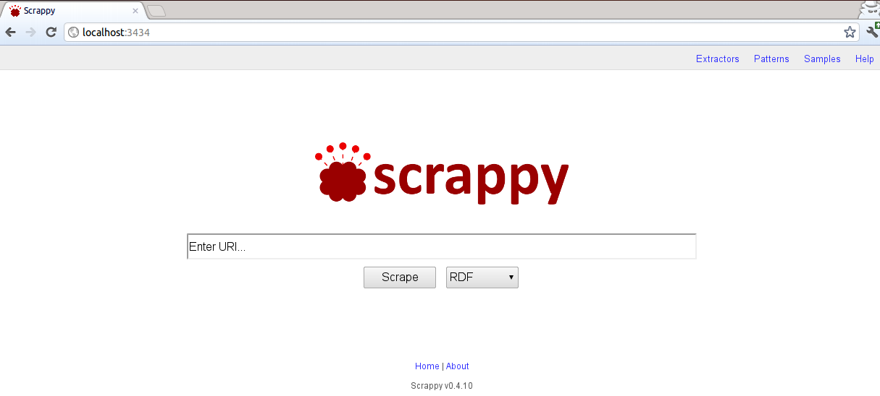Figure 1: Web admin interface of Scrappy
This interface also allows managing the extractors from each page (extractor tab, Figure 2), define visual patterns for improving the extraction (patterns) and train the extractors (samples tab). These last two tabs are still experimental facilities, so and end user would not need to use them.

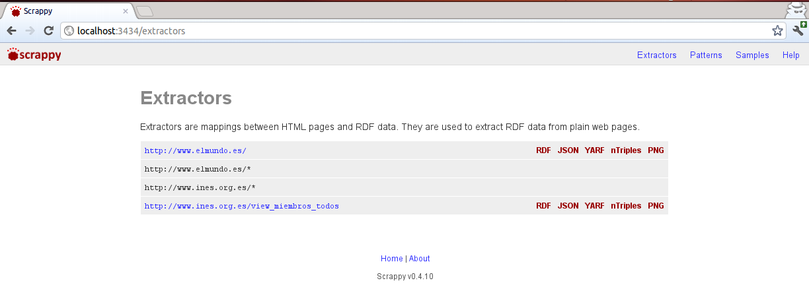Figure 2: Extractors Admin Interface

Web Service Interface
The web service interface provides a web service interface that mimics the admin web interface but for read-only operations.
$ scrappy -s
Launching Scrappy Web Server...
== Sinatra/1.1.3 has taken the stage on 3434 for production with backup from Thin

Ruby Interface
Scrappy can be used in a Ruby program by requiring the gem.
require 'rubygems'
require 'scrappy'
# Parse a knowledge base
kb = RDF::Parser.parse :yarf, open("https://github.com/josei/scrappy/raw/master/kb/elmundo.yarf").read
# Set kb as default knowledge base
Scrappy::Agent::Options.kb = kb
# Create an agent
agent = Scrappy::Agent.new
# Get RDF output
output = agent.request :method=>:get, :uri=>'http://www.elmundo.es'
# Output all titles from the web page
titles = output.find([], Node('dc:title'), nil)
titles.each { |title| puts title }

For example, to extract the data from http://www.larazon.es/, you will need:
require 'rubygems'
require 'scrappy'

# Parse a knowledge base
kb = RDF::Parser.parse :yarf, open("HOME_DIR/.scrappy/extractors/larazon.yarf").read
# Set kb as default knowledge base
Scrappy::Agent::Options.kb = kb

# Create an agent
agent = Scrappy::Agent.new
# Get RDF output
output = agent.request :method=>:get, :uri=>'http://www.larazon.es'
# This will return a graph object. To get the ntriples

# ntriples
ntriples = output.serialize :ntriples

# rdf
rdf = output.serialize :rdf

Integration with Sesame
Sesame functionality has been included in Scrappy. You can configure the repository options by editing the file config.yml placed the folder .scrappy, in your home dir. An example of this file can be found at the end of this README.
You can get the data for a certain period of time, by using the time (-t, –time) option:
$ scrappy -g example.org -t 3
This would get all the data stored in Sesame for example.org in the last 3 minutes.
In general, scrappy will look into its configuration file to know if the data stored in sesame can be considered valid.
This configurationg file (config.yml) must be placed in the .scrappy folder on the home of the user running scrappy. It has a number of options:
- host: The host where the sesame server is installed
- port: The port for the connection. Since sesame is installed over a tomcat, the default port is 8080
- time: The time the data is considered valid. You need to be carefull with this option: While scrapping over huge pages, it may spend a huge amount of time extracting the data. If the “valid” time is inferior to the time it takes scrappy to get the data, using the repository loses its meaming.
- Respository: The name you want scrappy to use to store the retrieved data.
- Format: Sesame accepts a number of formats, you can use either of them. However it's recommended to use ntriples. This will not affect the data output of scrappy.

# This is a sample configuration file, with the options to communicate with Sesame using
repository:
# The host were Sesame is. Do not add the trailing '/'
host: http://localhost
# The port for the connection
port: 8080
# The time to consider the data in the repository valid, in minutes
time: 15
# The name of the repository
repository: memory
# The format to communicate with the repository
format: ntriples
# You can use any of the following formats:
# rdfxml, ntriples, turtle, n3, trix, trig

However, while using omr, several modifications have been introduced into scrappy, in order to user both sesame and omr. The new configuration file includes the options to connect to both platforms:

# This is a sample configuration file, with the options to communicate with Sesame using
#Scrappy
repository:
# The host were sesame is. Do not add the trailing '/'
host: http://localhost

complete: openrdf-sesame/repositories

# The name of the repository
repository: memory

# The port for the connection
port: 8080

# The host were omr is. Do not add the trailing '/'
omr_host: https://localhost
omr_complete: omr-write/components
omr_user: omr-user
omr_pass: omr-pass
omr_port: 443

# The time to consider the data in the repository valid, in minutes
time: 5

# The format to communicate with the repository
format: ntriples

# You can use any of the following formats:
# rdf, ntriples, turtle, n3, trix, trig
In general, it has the same values as a normal scrappy config file has, but, also, several “omr” values:
- complete: how to complete the url for the sesame server.
- omr_host: The host where omr is installed
- omr_complete: how to complete the url for omr.
- omr_user: the user to connect with omr
- omr_pass: The password for the given user
- omr_port: The port for the connection. Since omr uses https, the default port is 443

Extractors
Extractors are based on the Scraping ontology and define mappings between HTML content and RDF data. More details about the Scraping ontology can be found in D5.2. An example of mapping is shown next, which allows extracting all titles from www.elmundo.es:
dc: http://purl.org/dc/elements/1.1/
rdf: http://www.w3.org/1999/02/22-rdf-syntax-ns#
sioc: http://rdfs.org/sioc/ns#
sc: http://lab.gsi.dit.upm.es/scraping.rdf#
*:
rdf:type: sc:Fragment
sc:selector:
*:
rdf:type: sc:UriSelector
rdf:value: "http://www.elmundo.es/"
sc:identifier:
*:
rdf:type: sc:BaseUriSelector
sc:subfragment:
*:
sc:type: sioc:Post
sc:selector:
*:
rdf:type: sc:CssSelector
rdf:value: ".noticia h2, .noticia h3, .noticia h4"
sc:identifier:
*:
rdf:type: sc:CssSelector
rdf:value: "a"
sc:attribute: "href"
sc:subfragment:
*:
sc:type: rdf:Literal
sc:relation: dc:title
sc:selector:
*:
rdf:type: sc:CssSelector
rdf:value: "a"

OMELETTE Mashup Registry

Installation of Sesame with uSeekM (+PostgreSQL +PostGIS)
Requirements:
- A Java Servlet Container that supports Java Servlet API 2.4 and Java Server Pages (JSP) 2.0, or newer. We recommend using a recent, stable version of Apache Tomcat. (http://tomcat.apache.org/)
- A recent, stable version of PostgreSQL Server (32Bit). (http://www.postgresql.org/download/windows/)
- PostGIS extension for PostgreSQL. (Can be installed with the Stack Builder that comes with PostgreSQL.)
- Extended Sesame HTTP Server with Indexing - USeekM (https://dev.opensahara.com/projects/useekm/wiki/HttpServer)
Installation steps:
- First install the PostgreSQL Server for Windows 32Bit (32Bit because the PostGIS extension is not yet 100% compatible with the 64Bit server and thus is not available in the Stack Builder Installer).
- After installing the PostgreSQL Server start the Stack Builder and select PostGIS 1.x under "Spatial Extensions" and install it to the running PostgreSQL instance.
- Start the pgAdmin tool to create a database user and database for your index.
- Create a new Login-Role (useekm is used as name and password in the example) with superuser rights.
- Create a new database (useekm is used as name in the example). Select the created user as owner. Choose "template_postgis" as template (IMPORTANT!).
- Your database should be good to go.
- Install Apache Tomcat and get it running. There should be no configuration needed.
- Download the latest useekm-http-server and useekm-http-workbench *.war files from https://dev.opensahara.com/nexus/content/repositories/releases/com/opensahara/
- You may rename them to openrdf-sesame.war and openrdf-workbench.war if you want to replace your current sesame installation.
- Put them in the Tomcat webapps folder. They should automatically get deployed.
- Your extended sesame server should be good to go.
- Create a configuration file for your indexed repository like this.
- The example indexes the http://purl.org/dc/elements/1.1/description predicate.
- You may need to edit the database connection settings, like username, password and the URL with the database name.

<beans xmlns="http://www.springframework.org/schema/beans"
xmlns:xsi="http://www.w3.org/2001/XMLSchema-instance"
xsi:schemaLocation="http://www.springframework.org/schema/beans http://www.springframework.org/schema/beans/spring-beans-3.0.xsd">
<!-- The id "repository" is mandatory! -->
<bean id="repository" class="org.openrdf.repository.sail.SailRepository">
<constructor-arg>
<bean class="com.useekm.indexing.IndexingSail">
<constructor-arg ref="sail" />
<constructor-arg ref="indexerSettings" />
</bean>
</constructor-arg>
</bean>
<!-- This example uses the NativeStore as the underlying sail, you could also use the MemoryStore -->
<bean id="sail" class="org.openrdf.sail.nativerdf.NativeStore" />
<!-- Please customize the indexer settings: -->
<bean id="indexerSettings" lazy-init="true" class="com.useekm.indexing.postgis.PostgisIndexerSettings">
<property name="defaultSearchConfig" value="simple" />
<property name="dataSource" ref="pgDatasource" />
<property name="matchers">
<list>
<bean class="com.useekm.indexing.postgis.PostgisIndexMatcher">
<property name="predicate" value="http://purl.org/dc/elements/1.1/description" />
<property name="searchConfig" value="simple" />
</bean>
</list>
</property>
<property name="partitions">
<list>
<bean class="com.useekm.indexing.postgis.PartitionDef">
<property name="name" value="description" />
<property name="predicates">
<list>
<value>http://purl.org/dc/elements/1.1/description</value>
</list>
</property>
</bean>
</list>
</property>
<!-- You can add additional configuration, such as index partitions to optimize performance. See the documentation. -->
</bean>
<bean id="pgDatasource" lazy-init="true" class="org.apache.commons.dbcp.BasicDataSource" destroy-method="close">
<property name="driverClassName" value="org.postgresql.Driver"/>
<property name="url" value="jdbc:postgresql://localhost:5432/useekm"/> <!-- CUSTOMIZE! -->
<property name="username" value="useekm"/> <!-- CUSTOMIZE! -->
<property name="password" value="useekm"/> <!-- CUSTOMIZE! -->
</bean>
</beans>

- Save this as configuration.xml to a folder in which the webapps have access to.
- Open the URL to the workbench in your webbrowser. (ex.: http://localhost:8080/useekm-http-workbench).
- Enter the URL to your Sesame server. (ex.: http://localhost:8080/useekm-http-server).
- Create a new repository.
- Choose USeekM Store as Type.
- Choose a name and ID.
- Press Next and enter the full path to the configuration file mentioned above. (use slashes instead of backslashes!).
- Press create and the repository and the tables in the database should get created and initialised.
Now you have the prerequisites to install the DataGridService for hosting your own OMELETTE Mashup Registry.

Installation of the DataGridService
We created an installable package for Windows to run a stand-alone DataGridService with all current features of the OMR and a RESTClient with a GUI (https://vsr.informatik.tu-chemnitz.de/demo/omr/omrsetup.zip). Just install the package and two folders will be created in the selected folder - one with the RESTClient and one with the DGS. Before starting the DataGridService you may need to configure it to connect to the correct Sesame triple store and repository. In the file “Server\DgsTestServer.exe.config” please set the following values corresponding to these you set up earlier during the installation of Sesame and the uSeekM repository:

<appSettings>
...
<!-- Service Registry -->
<add key="sesameStoreUrl" value="[Store URL,
i.e.: http://localhost:8080/useekm-http-server/]"/>
<add key="sesameRepository" value="[repository]"/>
<add key="sesameUsername" value="[username]" />
<add key="sesamePassword" value="[password]" />
</appSettings>

After you have done this just run the DgsTestServer.exe with administrative privileges. Now your OMELETTE Mashup Registry is ready for usage.

OMR Administrative interface

Installation
Requirements:
- OMR or Sesame 2.0 for testing.
- Apache 2 web server with PHP 5.2
Extract all the content wherever it's prefered. Before executing it, some configuration must be done.
The administrative interface can be configured to use a semantic data source by means of an OMR REST interface or a general SPARLQ endpoint. Within the project Omelette, it has been configured to use both the OMR interface (as described in section 2.2.4) or a Sesame Open-rdf Workbench, which has been used for testing purposes.
The semantic data source is configured in the omr.php class file.
There are two kinds of URL to be configured.
- To configure the URL of the SPARQL endpoint, the $server variable must be configured.
- OMR: https://vsr-web.informatik.tu-chemnitz.de/omr-write/components/sparql
- Sesame: http://shannon.gsi.dit.upm.es:18080/openrdf-workbench/repositories/repository/query
- It is also necessary another URL where the data to be added to the repository is posted. This is defined by $post_url
- OMR: https://vsr-web.informatik.tu-chemnitz.de/omr-write/components/
- Sesame: http://shannon.gsi.dit.upm.es:18080/openrdf-workbench/repositories/repository/add
Both can be configured at the same time. In order to switch between the endpoint to use, it is just needed to change the value of the variable $endpoint, and select {“omr”,”sesame”}
Once the system has been configured, the OMR admin is ready to be used. Just open a browser with the url corresponding to the path where it was extracted, and the system will show the admin screen as shown in the following picture.

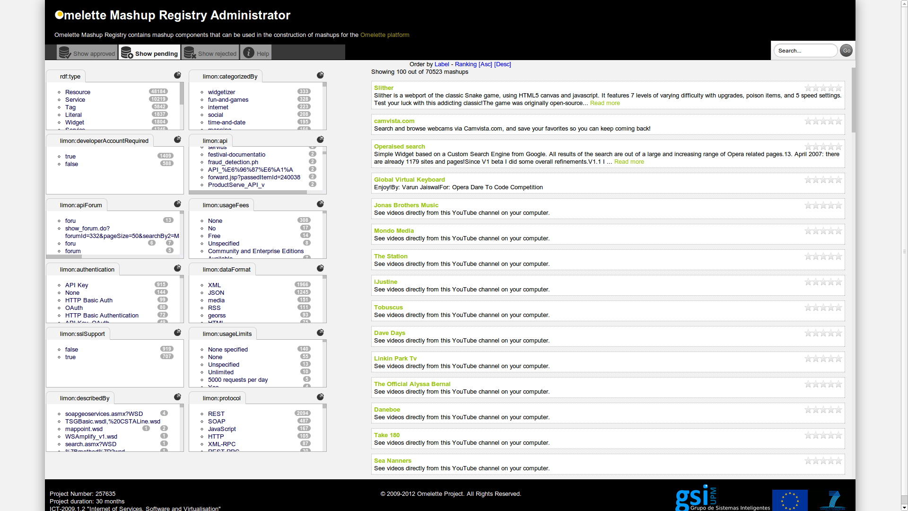Figure 3: Main view OMR Administrator

How it works
In the main view of the OMR Administrator it is shown a top menu:

Figure 4 OMR Admin top menu

- Show approved, shows those mash-ups which has been selected by the administrator as approved.
- Show pending, shows everything that is scrapped.
- Show rejected, shows rejected mash-ups.

Show approved

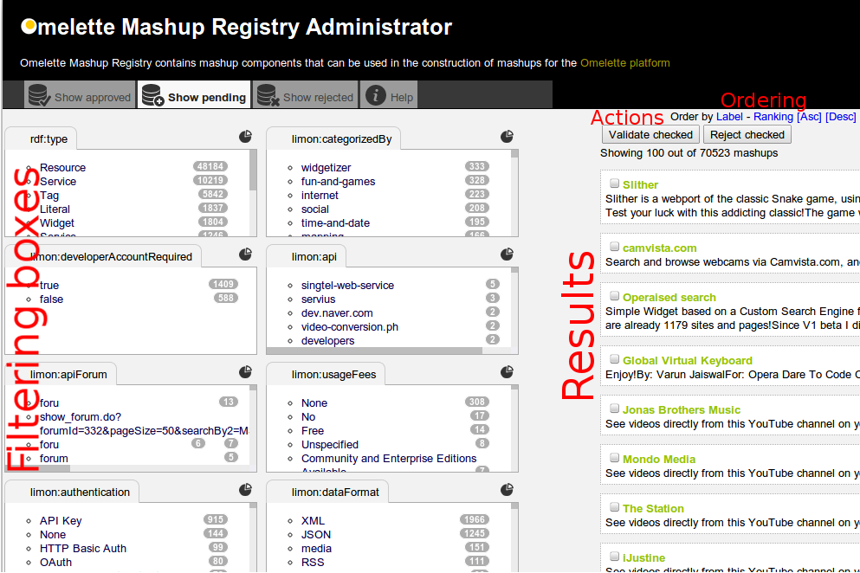Figure 5: Admin interface
Clicking on the elements from the filtering boxes will filter the results shown on the right, helping us to find what we need.
You can also use the search box to find something by name or description and the ordering.

Figure 6: Search box

On mouse over the title of a filtering box help is provided:
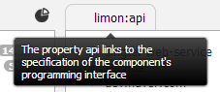Figure 7: Filtering box

Clicking on the icon situated on the right of the title in the filtering box pop-ups a screen with detailed graph that shows how many widgets populate each section:

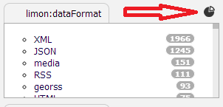Figure 8: Statistics

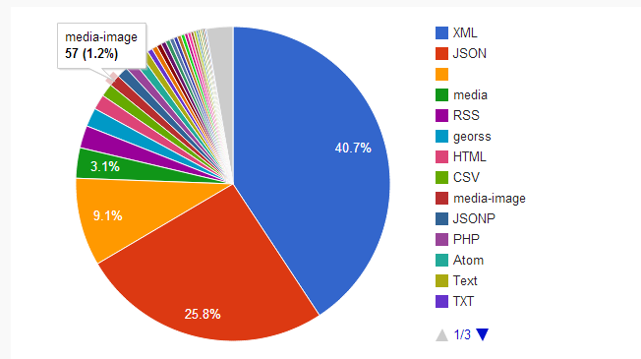Figure 9: Pie chart

The working method on “Show approved” and “Show rejected” screen is mostly the same as “Show available”, but we will not be able to mark them as rejected or approved as they are already

Example
Need some map widget with the following specifications:
- Free
- JSON fot data format
- Uses REST interface
First of all we can search by keyword “maps”, afterwards, to make it more accurate, we select our criteria on the filtering boxes. We will get this results (example):

- RentRent API
Use the RentRent API to return the rentals listed on Craigslist. You can search for rooms, apartments, or houses, and you can provide a parameter so that you only return rooms.. Also, you can provide parameters for min and max... Read more
- Ordnance Survey OpenSpace API
API documentation is publically available from the OpenSpace web site. From their site: OS OpenSpace is a free Ordnance Survey service that allows you to embed Ordnance Survey. Place any kind of i... Read more
- Spot2be API
The Spot2.be API and service tries to solve the location, addresses, maps and directions hassle by combining all important data it all in one simple tiny link. Spots can be sent and opened via internet... Read more

Clicking on the title or the read more hyperlink will show us more information about the component.
We select the widgets wanted by clicking on “validate checked”
Figure 10: Validation

- After validating/approving, it will be shown in the “Show approved” screen.
- After rejecting, it will be shown in the “Show rejected” screen.

OMELETTE Ranking System

Introduction
The Omelette Ranking System is a Java tool that classifies different web services and mashups through a ranking. Its goal is to support the administrator in validating the discovered services. It could also be used for assisting the developer in selecting a discovered component..
Its code is available at https://github.com/adri87/Metadirectory.git.

Installation & User Manual

Requirements:
- Sesame 2.6
- Stable version of Apache Tomcat. (http://tomcat.apache.org/)
Installation steps:
- First download the ranking system´s code available at project´s repository.
- Once downloaded it, extract the content wherever it´s prefered.
- In the next step,it's necessary configure the ranking system. To this, it looking for the file “configuration.propierties” in root folder. This file will allow us adjust the parameters of our connection to the database. This database must contain information over mashups,apis and its form of connect between them Linked Mashups Ontology.
- Open the file “configuration.propierties” with a text plain editor and fill the fields with information that correspond just like can see in the next chart.

# DataBase Server
dataBaseServer= Put here the URL of the sesame´s data base

# Repository
repository= Put here the respository´s name

# DataBase Repository Update
repositoryUpdate= Put here URL where the data to be added to the repository is posted.

- Once the system has been configured, the Omelette ranking system is ready to be used.
- Download and install software Eclipse http://www.eclipse.org/downloads/.
- Open Eclipse and import the ranking system´s project. For it:
  - Go to File -> Import.
  - Select Existing Projects into Workspace.
  - Click the radio button next to Select archive file and click the Browse button on the following dialog.
  - Find the archive file on your hard disk. Click Open to select it.
  - Click Finish to perform the import.
  - The project should now appear in your Project Explorer view.

- With Eclipse we export the project like a .jar executable. So we must click on fille->export->Java->Runnable Jar->picked our project and then we give the jarfile name and we specifie the directory where it should be created it.
- Now, we create a script. For this, open a text plain editor and copy:
#!/bin/bash
echo program ranking omelette
cd / directory where is the file .jar that we create it
java -jar jarFileName.jar
- Save the file.
- Finally through the command line and execute the follon instruction:
$ ./NameOfScript

- After running the program, it will have been introduced the fields for the different ranking algorithms in the sesame´s database: limon:DegCent, limon:ClosCent and limon:RatSoc correspondingly. These fields represents the distinct mechanisms that we have it to evaluate like service is important compared another.
- This information will be updated preiodically by a timer.

How it works
The Omelette ranking system acts about a metadirectory consisting of web services, mashups as well as widgets. This metadirectory must makes use of the Linked Mashups Ontology (LiMOn), a unified model for those components, which integrates information.
The ranking sytem proporcionates indicator for a web service's relevance through some algorithms.To explain the different mechanisms. Let S be the set of web services whereas M is the set of mashups in our dataset. We reduced the intuitive hypergraph to an undirected and bipartite graph G = (V,E) letting the set of vertices V = S U M be the union of S and M. The set of edges was defined as E = { (s,m) | Mashup m uses the API of service s.} The next figure illustrates the structure of this graph:
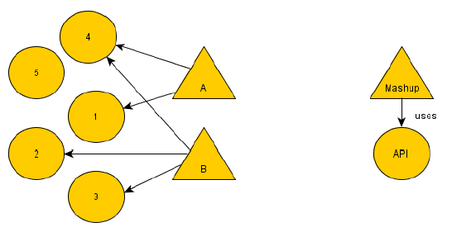
Figure 10: Ilustration of the Mashup-API-Graph

We now simplify this graph a bit. We now have a bipartite, disconnected and undirected graph G, where the calculations of the centralities are done on this simplified and the distinction between APIs and mashups is not relevant.
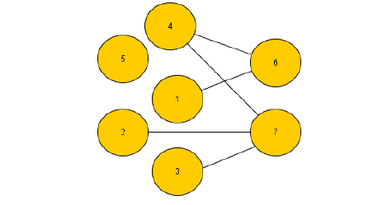
Figure 11: Ilustration of the simplified Mashup-API-Graph

The following ranking functions have been developed:
1. Degree centrality
It's defined as the number nodes that are directly connected to node envelope which it is calculated the degree centrality. In our scenario the number of mashups that use a certain service, which reflects the popularity.
For it the system looking for the label "limon:uses" inside of the database. It Count the number of these labels and assigns this value like web service's degree centrality.
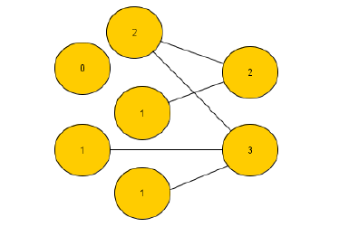
Figure 12: Ilustration of Degree Centrality
2. Closeness centrality.
Is a natural distance metric between all pairs of nodes that it has defined by the length of their shortest paths. The farness of a node s is defined as the sum of its distances to all other nodes and its closeness centrality is defined as the inverse of the farness.Thus, the node with the value higher the shorter the geodesic distances between itself and other nodes. Closeness centrality can be regarded as a measure of how fast it will take to spread information from node s to all other nodes sequentially. This centrality has implemented in our case with an extension as (Opsahl, Agneessens and Skvoretz 2010) propose and a modification of Brande´s algorithm too. . Closeness centrality is an important technique in social network analysis.
For it, our system utilizes the label "limon:uses" as the last time. Thereafter it creates a graph that represents all the connections between services. Once this is done, it using Dijkstra´s algorithm to calculate the geodesic distance each service. In other words, the node´s closeness centrality.
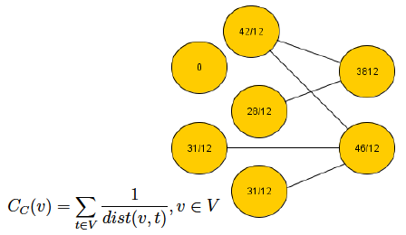
Figure 13: Illustration of the closeness centrality

3. Google Search Engine
This algorithm utilizes the amount of hits the Google Search Engine returned querying it for the web service’s name and limiting the results to the domain of StackOverflow3 , a question-and-answer website specialized on programming topics, is an indicator of how widespread a web service is among de- velopers.
Futhermore ranked each node according to number facebook likes or Twitter tweets. For this it has utilized the scrappy technology to extract these parameters of the differents pages. So, social centrality sorts the nodes by popularity, give us an idea of its use and extension. Summarizing each node has a punctuation that is correspond with its social importance.
4.PUR
The score ranging from 0 to 5 each web service has on user rating functionality which measures the degree of satisfaction the users had when working with a specific API.

Finally the Normalized Discounted Cumulated Gain (nDCGi) metric has been applied to each simple ranking function. Te nDCGi metric is based on DCGi, wich is defined as follow in our scenario:

To more information consult document “the Ranking Web Services using Centralities and Social Indicators”[http://gsi.dit.upm.es/index.php/en/component/jresearch/?view=publication&task=show&id=271].

User manual

The OMR provides a REST interface which is illustrated in this section. The following usage scenarios will help you get started.
Create a new resource for storing semantic component descriptions:
POST /omr HTTP/1.1
Host: datagridservice.example.org
Content-Type: text/xml
Content-Length: xxx
<collection xmlns="http://www.w3.org/2007/app" xmlns:atom="http://www.w3.org/2005/Atom" xmlns:dgs="http://www.webcomposition.net/2008/02/dgs/">
<atom:title>components</atom:title>
<dgs:dataspaceengines>
<dgs:dataspaceengine dgs:type="http://www.webcomposition.net/2008/02/dgs/DataSpaceEngines/ServiceRegistryDataSpaceEngine" />
</dgs:dataspaceengines>
</collection>

Add new data to the OMR:
POST /omr/components HTTP/1.1
Host: datagridservice.example.org
Content-Type: text/xml
Content-Length: xxx
<rdf:RDF xml:base="https://datagridservice.example.org/omr/components/graphs/1705f351-db6e-4037-899c-08156ab31e13" xmlns:rdfs="http://www.w3.org/2000/01/rdf-schema#" xmlns:xsd="http://www.w3.org/2001/XMLSchema#" xmlns:ns0="http://www.ict-omelette.eu/schema.rdf#" xmlns:rdf="http://www.w3.org/1999/02/22-rdf-syntax-ns#">
<ns0:Widget rdf:about="http://eco.netvibes.com/themes/368491/wasabi">
<ns1:description xmlns:ns1="http://purl.org/dc/elements/1.1/">Official theme for Netvibes Wasabi</ns1:description>
<ns2:source xmlns:ns2="http://purl.org/dc/elements/1.1/" rdf:resource="http://eco.netvibes.com/themes/368491/wasabi" />
<ns3:isPartOf xmlns:ns3="http://purl.org/dc/terms/" rdf:resource="https://datagridservice.example.org/omr/components/graphs/1705f351-db6e-4037-899c-08156ab31e13" />
<ns0:categorizedBy>Textures; Official</ns0:categorizedBy>
<ns0:endpoint rdf:resource="http://widgets.opera.com/widget/download/force/10322/1.0/" />
<ns0:hasRegistryEntry rdf:resource="http://datagridservice.example.org/omr/components/feedItem?name=https://datagridservice.example.org/omr/components/graphs/1705f351-db6e-4037-899c-08156ab31e13" />
<ns4:installs xmlns:ns4="http://www.netvibes.com/#">29678</ns4:installs>
<ns5:regions xmlns:ns5="http://www.netvibes.com/#"></ns5:regions>
<rdfs:label>Wasabi</rdfs:label>
</ns0:Widget>
</rdf:RDF>

Get all available components registered in OMR:
GET /omr/components HTTP/1.1
Host: datagridservice.example.org
Accept: text/xml

<feed xmlns="http://www.w3.org/2005/Atom">
<title type="text">Available Components</title>
<subtitle type="text">Component descriptions</subtitle>
<id>http://datagridservice.example.org/omr/components</id>
<updated>2012-05-30T15:42:26+02:00</updated>
<link rel="meta" type="application/rdf+xml" title="Feed metadata" href="http://datagridservice.example.org/omr/components/meta" />
<link rel="views" type="application/atom+xml" title="Views on RDF dataset" href="http://datagridservice.example.org/omr/components/views" />
<link rel="sparql" type="application/sparql-results+xml" title="Sparql endpoint" href="http://datagridservice.example.org/omr/components/sparql" />
<link rel="sparql-update" type="application/sparql-results+xml" title="Sparql-Update endpoint" href="http://datagridservice.example.org/omr/components/sparql-update" />
<link rel="data" type="application/rdf+xml" title="RDF dataset" href="http://datagridservice.example.org/omr/components/graphs/all" />
<link rel="search" type="application/opensearchdescription+xml" title="OpenSearch endpoint" href="http://datagridservice.example.org/omr/components/opensearch/document" />
<entry>
<id>https://vsr-web.informatik.tu-chemnitz.de/omr/components/graphs/bf5cdceb-38c7-4a0c-b5ed-49f1eae6bfa2</id>
<title type="text">Wasabi</title>
<summary type="text">Official theme for Netvibes Wasabi</summary>
<published>2012-05-30T15:42:27+02:00</published>
<updated>2012-05-30T15:42:27+02:00</updated>
<link rel="edit-media" type="application/rdf+xml" href="http://datagridservice.example.org/omr/components/graphs/?name=https://vsr-web.informatik.tu-chemnitz.de/omr/components/graphs/bf5cdceb-38c7-4a0c-b5ed-49f1eae6bfa2" />
<link rel="edit" type="application/atom+xml;type=entry;" href="http://datagridservice.example.org/omr/components/feedItem?name=https://vsr-web.informatik.tu-chemnitz.de/omr/components/graphs/bf5cdceb-38c7-4a0c-b5ed-49f1eae6bfa2" />
<content type="application/rdf+xml" src="http://datagridservice.example.org/omr/components/graphs/?name=https://vsr-web.informatik.tu-chemnitz.de/omr/components/graphs/bf5cdceb-38c7-4a0c-b5ed-49f1eae6bfa2" />
</entry>
...
</feed>

Creation of example view for searching components by their description (SPARQL template):
POST /omr/components/views HTTP/1.1
Host: datagridservice.example.org
Content-Type: text/xml
Content-Length: xxx

<?xml version="1.0" encoding="utf-8"?>
<entry xmlns="http://www.w3.org/2005/Atom">
<title type="text">services</title>
<content type="application/xml+vnd.omr">
<omr:view xmlns:omr="http://www.ict-omelette.eu/schema.rdf#omr">
<omr:url>?query={query=}</omr:url>
<omr:sparql>
<![CDATA[
PREFIX pdc:<http://purl.org/dc/elements/1.1/>
PREFIX search:<http://rdf.opensahara.com/search#>
SELECT DISTINCT ?result
WHERE
{
?result pdc:description ?description.
FILTER search:text(?description, "{query}")
}
]]>
</omr:sparql>
</omr:view>
</content>
</entry>

Execute view to get all components matching a given query string:
GET /omr/components/views/services/data?query=geo HTTP/1.1
Host: datagridservice.example.org
Accept: application/sparql-results+xml

<?xml version="1.0" encoding="utf-8"?>
<sparql xmlns="http://www.w3.org/2005/sparql-results#">
<head>
<variable name="result" />
</head>
<results>
<result>
<binding name="result">
<uri>http://geoservice.example.org</uri>
</binding>
</result>
</results>
</sparql>

In order to manage the components of the interface, admin users can access the admin interface (Figure 11). The current version can be used for ranked search of components. Next versions of the interface will provide facilities for component approval and make them available to developers.
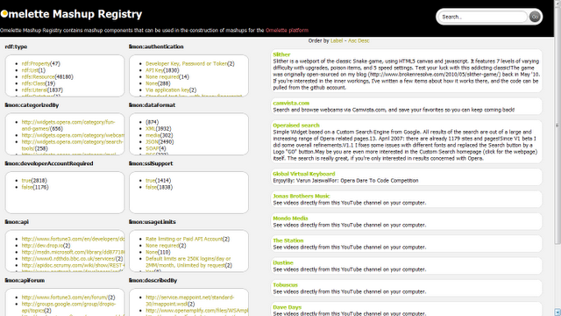Figure 11: OMR administrative interface

Automatic Composition Tools

Automatic Composition Engine (ACE)

Introduction
The Automatic Composition Engine – called ACE – is an essential part of the automatic composition approach realized in the context of the OMELETTE project, as it is use to acquire user goals, to analyse them and to find suitable widgets matching these goals.
ACE consists of a dialogue agent and a widget selection module. The dialogue agent holds a conversation with user to identify his goals and preferences and finally issues a SPARQL query, which can be used to select appropriate widget descriptions from the OMR. The dialogue agent can be configured with a knowledge base, defining the domain and goal model. The conversation is driven by a set of rules, which are processed at run-time by Drools rule engine. We developed a dedicated domain specific language (DSL) to simplify the process of domain and goal knowledge modelling.

Installation
Requirements:
- the current prototype of the Automatic Composition Engine is implemented as a Java console application. As a consequence, executing ACE is not restricted to a certain platform or operating system. However, it is required to have the current version of the Java Runtime Environment (JRE) installed on the system to be used.
Installation:
- ACE can be downloaded as a zip-compressed archive from:
http://vsr.informatik.tu-chemnitz.de/demo/ace/dialogagent.zip
- After downloading and extracting the archive, the following exemplary rules can be defined to configure the dialog agent (using a dedicated Domain Specific Language):
1) rule "Entertainment"
when
There is Travelling
then
Ask Yes-No Question: "Are you interested in entertainment places (y/n)?"
if(Answer is yes)
Remember fact: Entertainment()
end
2) rule "Accommodation"
when
There is Travelling
then
Ask Yes-No Question: "Do you need help in accommodation (y/n)?"
if(Answer is yes)
Remember fact: Accommodation()
end
3) rule "Restaurants"
when
There is Entertainment
then
Ask Yes-No Question: "Are you interested in restaurants (y/n)?"
if(Answer is yes)
Remember fact: Restaurants()
end
4) rule "RestaurantsDetails"
when
There is Restaurants
then
Ask Question with Multiple Choice: "Which type of food do you prefer (comma-separated list)?"
Copy answer to keywords list for the above fact
end

User manual
The following command needs to be executed from a command line interface within the directory containing the ACE library files:
java -cp "dialogagent.jar;drools-core.jar;knowledge-api.jar;drools-compiler.jar;org.eclipse.jdt.core_3.7.1.v_B76_R37x.jar;antlr-runtime.jar;mvel2.jar;xstream.jar" com.sample.DialogAgent
On Windows operating system the dialogagent.bat file can be used as a shortcut encapsulating the above command.
These definitions made during the configuration of ACE result in dynamic conversation flows, which vary depending on the user’s input. This fact is illustrated in the two screenshots below. In the first scenario (Figure 12) the user answered that he is in fact in Berlin while in the second scenario (Figure 13) the user negated this, which in turn led to a sequence of adapted questions:
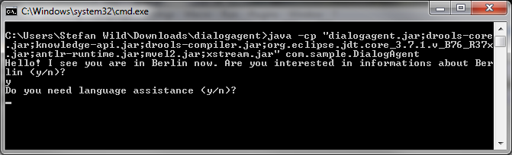Figure 12: ACE – Begin of Conversation with User
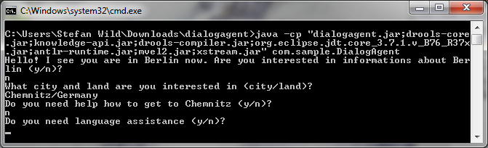Figure 13: ACE - Dynamic Adaptation of Conversation based on User Input

A complete conversation with the user is depicted in the next screenshot (Error: No se encuentra la fuente de referencia):

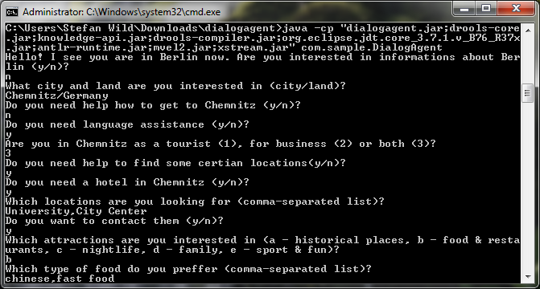Figure 14: ACE - Complete User Conversation

When the conversation with the user is completed, ACE automatically derives goals on the basis of the facts gathered in the questionnaire. The following screenshot (Figure 4.4) illustrates the evidences collected during the conversation.
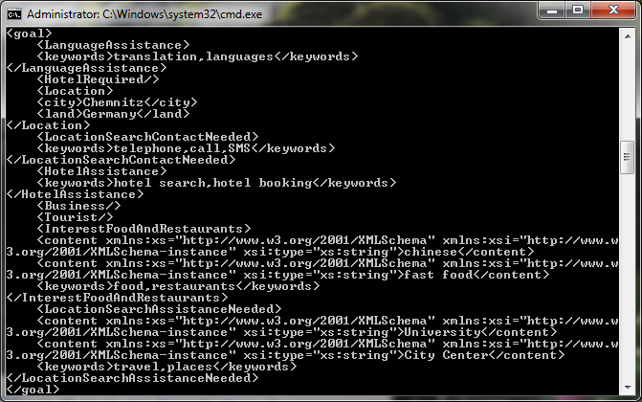Figure 15: ACE – Goals derived from User Conversation

Afterwards, the evidences are directly passed to the widgets selection module, which applies internally-defined rules to select appropriate widgets from OMR (Error: No se encuentra la fuente de referencia):
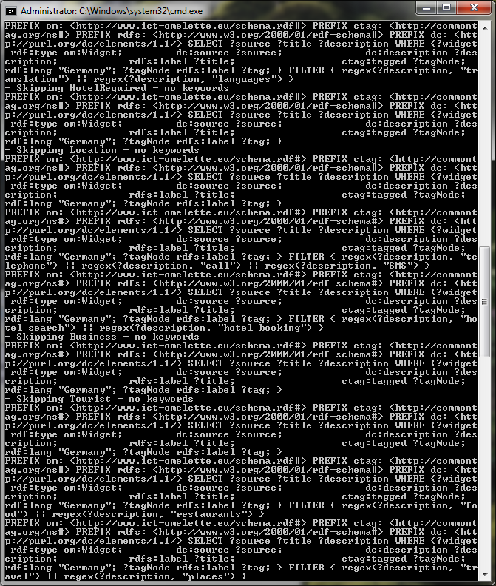Figure 16: ACE - SPARQL Queries generated from Gathered Goals
Currently one step is implemented, which queries OMR for given keywords. Further steps may exclude widgets if they do not satisfy parts of user goals, e.g. use commercial services or provide content in a language, which user is not comfortable with.
.

OMELETTE widget orchestration engine

Introduction
The objective of this section is to present a concise user manual for an OMELETTE widget orchestration engine developed as a part of WP5 activities and which is also used for WP6 for building a prototype workspace for the First Line Support.
This software is a PoC for Omlette widget orchestration. It shows the capability of Inter-Widget communication (IWC). It consists of a fully functional user workspace composed of individual widgets that helps a user to achieve his/her goal(s).
What can this software do?
When a workspace is loaded and widgets are initialised they start emitting events within a browser window.
- Different widgets inform the workspace about names of input fields they contain.
- Geo-location widget try to get a location information through the GPS interface implemented by a host browser (ask permissions from a user).
- Based on the input fields names (“when”, “where”, etc.) engine automatically wires emitted events with possible handlers, i.e. if a user has inserted “pizza” in one of the input fields named “what” then an engine will populate all other “what” fields in widgets that constitute that workspace.
This is a rather simple but at the same time quite effective mechanism for auto-wiring widgets that do not designed to work with each other and even are not aware of existence of others. This approach allows extensions in the future such as filtering event or registering to specific events automatically or with a user assistance. Further on, it is possible to use machine learning and semantics to improve automatic wiring in the future as well.
What will the software NOT do?
- The software doesn’t react based on any intelligent decision algorithm related to user’s previous behaviour or semantics associated to the input names currently.
- The software doesn’t store captured user behaviour in a shared (external database) currently. It is stored now in session storage.
- This software doesn’t support IWC extra workspace scenarios extensively.

Installation
- Download a java web application archive file from http://pom.nu/KLKZNM
- Drop the tie_woe.war file into the webapps (or deploy) directory on your application server, e.g. Apache Tomcat or any other compatible server
- Start the application server.
- Then open the address http://<yourhost>:<yourport>/tie_woe/container/omelette/ in Google Chrome, if the deployment is under Apache Tomcat

User Manual

Initial screen
A screenshot below demonstrates a state of a workspace just after initialisation of widgets that constitute that workspace. Please, note two auxiliary widgets that are populated automatically just after the start. The first one contains a list of all input fields found in the workspace with their name that are used as types for emitted events. The second one can fetch a user geo-location if the user allows it through the dialog initiated by his/her browser.

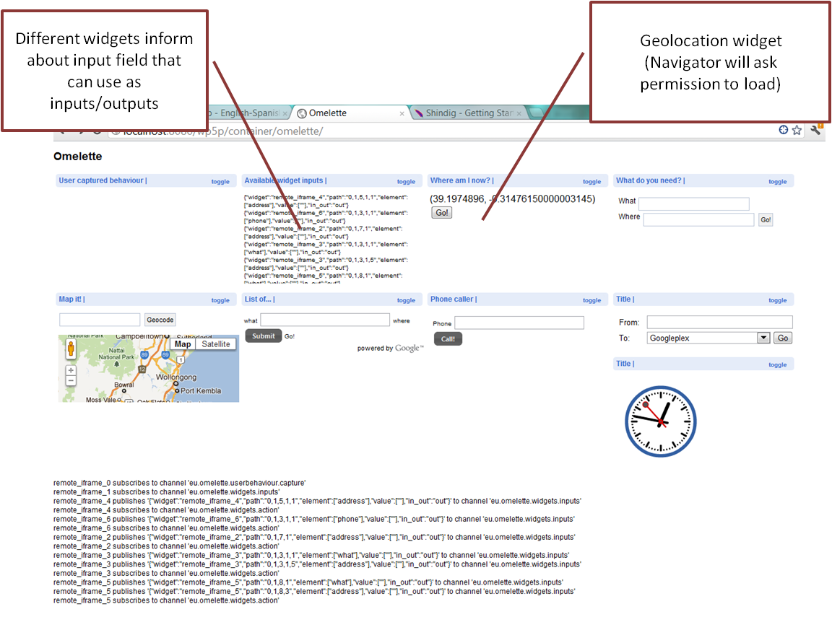Figure 17: Initial screen

Once the workspace is loaded, different kind of widgets can be observed:

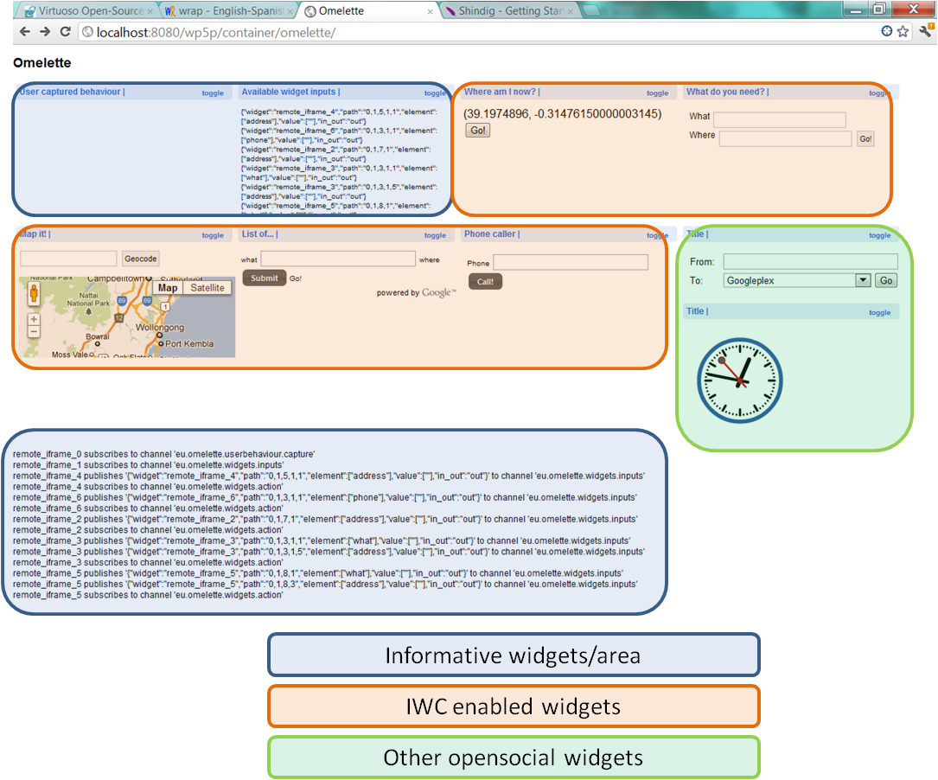Figure 18: Workspace populated with widgets

The user can interact with any of the widget, but only widgets that contain input fields would be able to automatically react on user’s actions.

Capturing a user behaviour

Try to ‘copy&paste’ or ‘drag&drop’ information between widgets.

The output action (copy or drag) will be shown in red on the "User Captured behaviour" widget, and the input one (paste or drop) will be drawn in blue.

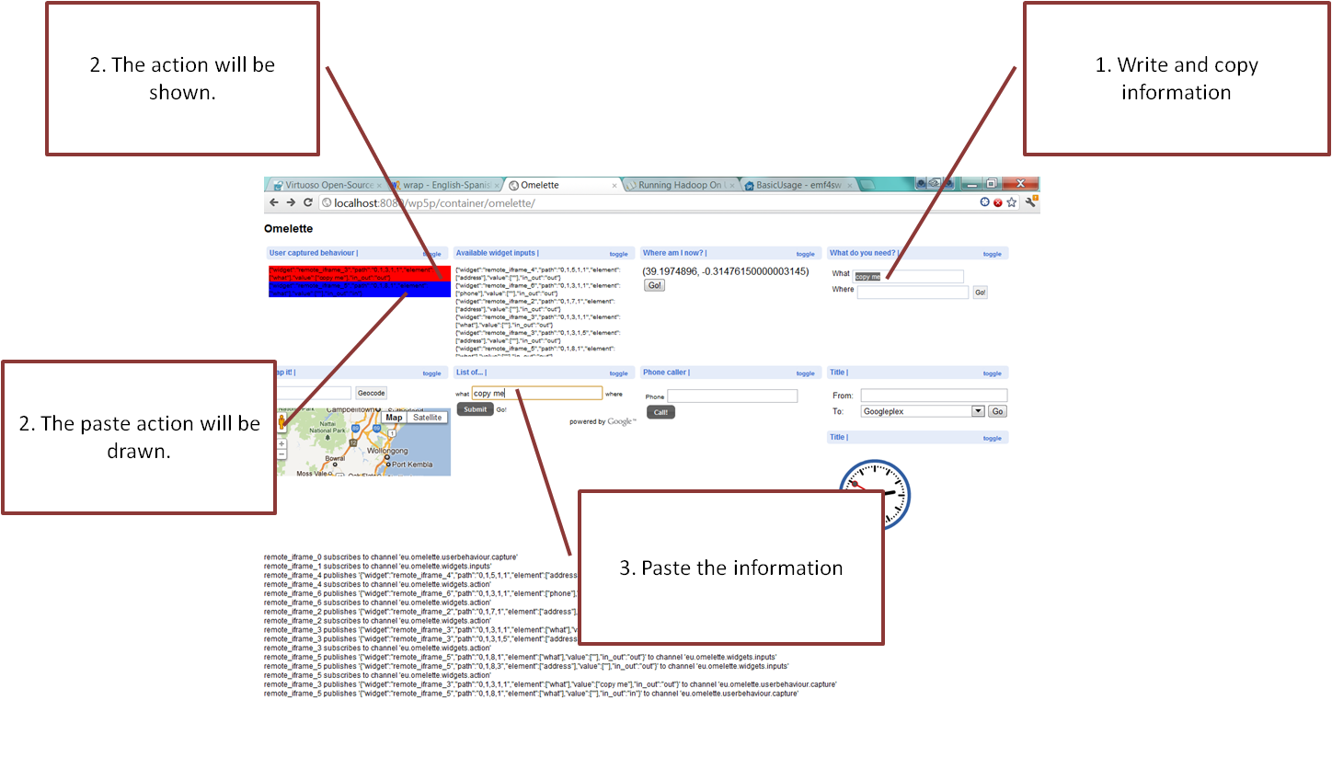Figure 19: Capturing user behaviour

For each action the following information is captured:
  - Widget: Id of the widget (corresponds to the iframe that contains the widget).
  - Path: a representation of the xpath (relative to the widget) of the element that triggered the event.
  - Element: name of the element that triggered the event.
  - Value: value of the input element.
  - in_out: if the event is an ‘in-action’ or ‘out-action’.
This information is meant to be stored in an external database, so that it can be reused afterwards in different workspaces where the pair of widgets affected by the user actions appears.

Capturing form submission and broadcasting of information
When a user submits an information related to this action this information is broadcasted to all widgets which might be interested in it, i.e. widgets that might make use of the information. Those widgets can process the information and decide if they can react or not to this action.
Currently widgets can just react on the submitted events, if they have an input field which name is equal to the name of the element that has triggered the event on another widget.
If in the workspace, the button “Go!” is pressed on the “Where am I now?” widget, the information will be processed by the widgets that have some field related to position (e.g. “where”). These widgets will react on the action by automatically submitting this new input, and so, updating their content.
The next screen demonstrates capturing a form submission and broadcasting information to other widgets that are subscribed for this type of event.

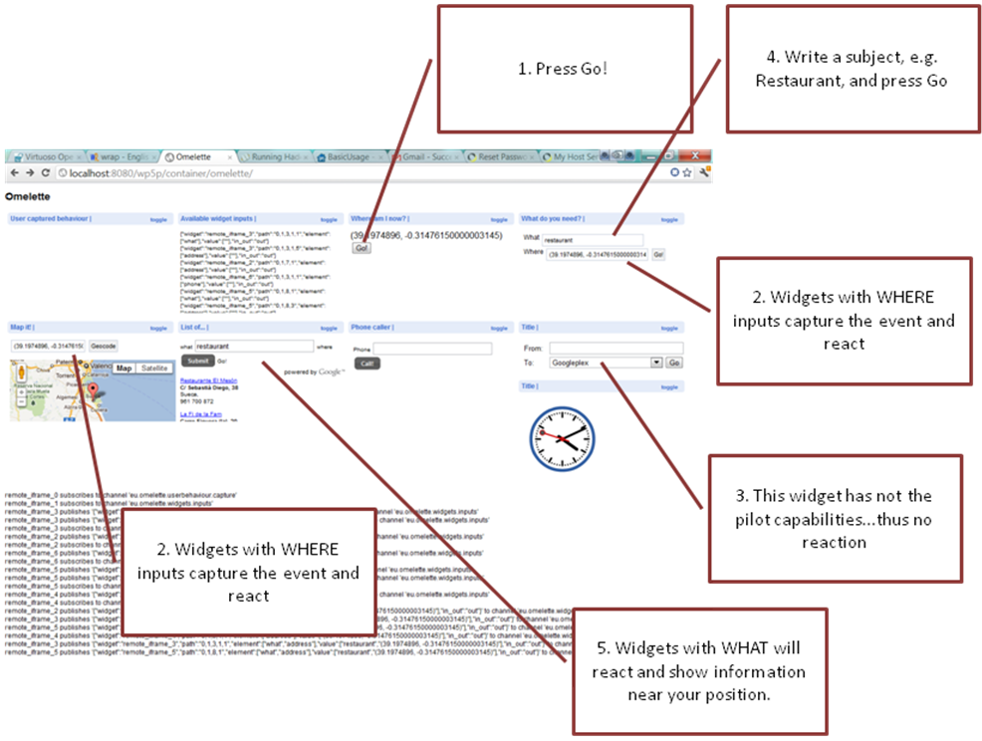Figure 20: Form submission and broadcasting of events

From there on, try to change the “what” and “where” input fields and observe how the workspace reacts to the form submission events.

Browser Support
- The current implementation has been tested under Google Chrome (due to Shindig limitations).
- The current implementation also supports Mozilla Firefox and Opera Labs browser version (which typically will be used for capturing user camera on browser).
- It still needs to be tested on Safari and it doesn’t support Internet Explorer.
Glossary
- DOM: Document Object Model, a convention for representing and interaction with objects in HTML, XHTML and XML documents.
- IWC: Inter Widget Communication, a technique which allows widgets to exchange information among each other.
- PoC: Proof of Concept, is a realization of certain idea to demonstrate its feasibility.
- PubSub: Publish Subscribe (Model/ Technique) is a messaging pattern which allows subscribers to receive the message for which they have subscribed, when it is published. This pattern provides greater network scalability and more dynamic network topology.
- Widget orchestration: The co-ordination between multiple widgets managed by their run time environment based on certain rules.

Conclusions
Through this deliverable, the different tools that comprise OMELETTE's WP5 ecosystem have been described. As said, different tools allow performing ranked component discovery out of web repositories, automatic composition of workspaces out of user goals, and widget orchestration for the execution of such workspaces.
Next steps involve integrating the OMR with other components as well as a PubSub notification mechanism. The automatic discovery tools and administrative interface will be integrated with the rest of OMELETTE components in order to automatically populate the OMR and deploy widgets and services to the respective runtime environments. The Automatic Composition Environment will be extended with the algorithms described in D5.3 and integrated into the Live OMELETTE Environment.

The current JRE release is available at http://www.oracle.com/technetwork/java/javase/downloads/index.html

